1. Explain what the simple List component does.

An array of text is passed to the list component as prop items. The List component is wrapped inside the memo function as "WrappedListComponent". This memo function enhances the performance of this component by memoizing the result, which means that React will skip rendering the component and reuse the last rendered result. Then in the WrappedListComponent component, we are using the useState hook to track the index of the items present in the item array by using useEffect and setting its value to null whenever the items array changes.

Then we use the map function to render each item from the items array individually, by making a separate component "SingleListItem" and passing all the values to it via props, which is also wrapped inside the memo function as "WrappedSingleListItem". Then in this component, we render each item of the list with a background colour of green, if isSelected != null and red if isSelected = null. This component is outputing an item in the "li" tag for the parent "ul" tag, which is present in the WrappedListComponent.

Aside from all this, we are using propTypes  which is used to make sure that the passing value to the variable is the correct datatype. The datatype that we decided to be in.

1. What problems / warnings are there with code?  
     
   The first problem in the code is with the isSelected prop that we are passing to the SingleListItem.  
   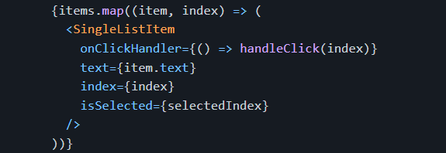  
      
     
     
     
     
     
     
     
     
   The isSelected is an boolean prop,   
   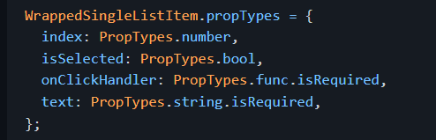  
     
     
     
     
     
     
     
   So we can’t pass a number to it. Since index is a number prop, and the value of index is directly set in the setSelectedIndex inside the handleClick function, then we are using it to set the value of isSelected.  
     
   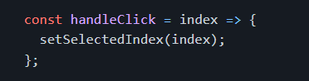

The second problem is with the propTypes.shapeof function. Because there is no such function.  
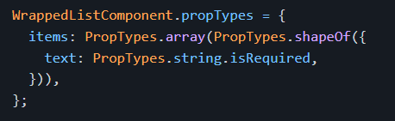

1. Please fix, optimize, and/or modify the component as much as you think is necessary.

To fix the first problem, we can change the handleClick function in the WrappedListComponent. Rather than directly setting the index value to the setSelectedIndex, we can first match the index value to the item in the list that matches the selected item, and then set the setSelectedIndex value to True.

Alternatively, we can simply change the propType of isSelected to a number.

For the second problem, we can simply use the correct function PropTypes.shape() in place of the wrong function.